

**PURBANCHAL UNIVERSITY**

**KULESHWOR AWAS CAMPUS**

**FIRST SEMESTER PROJECT**

**ON**

**“Personal Diary Application”**

In the partial fulfillment for the requirement of the first Semester Project-I (Subject Code- …BIT 106 CO…) in the Completion of Bachelor of Information Technology (BIT)

Degree at Kuleshwor Awas Campus, under Purbanchal University.

**Submitted By:** **Submitted To:**

**Name: Sampada Shrestha**  **– R.N:-312121** **Purbanchal University**

**: Binju Wagle** **– R.N:-312101**

**STUDENT’S DECLARATION**

We following students, hereby declare that the Project Report titled "Personal Diary Application**"** is a result of our own work and our indebtedness to other work Publications, references, if any, have been dully acknowledged. If we are found guilty of copying any other report or published information and showing as our original work, we understand that we shall be liable and punishable by Purbanchal University, which may include fail in examination, ‘Repeat study and re-submission of the report' or any other punishment that Purbanchal University may decide.

We further certify that this Project submitted in partial fulfillment of the requirement for the award of Bachelor in Information Technology (BIT) of the Purbanchal University is our original work and has not been submitted for award of any other degree or other similar title or prizes.

|  |  |  |  |  |
| --- | --- | --- | --- | --- |
| S.N | NAME | REGISTRATION NO. | ROLL NO. | SIGNATURE |
| 1. | Sampada Shrestha | 177-3-2-01987-2024 | 312121 |  |
| 2. | Binju Wagle | 177-3-2-01968-2024 | 312101 |  |

**ACKNOWLEDGEMENTS**

We take this opportunity to express our profound appreciation and unfathomable regards to the Information Technology (IT) department for this commendable guidance, monitoring and constant encouragement throughout the course of this project. The help and guidance given by shall carry us a long way, in the journey on which we are about to embark.

We also take this opportunity to express a deep sense of gratefulness to Mr. Nabin Dhital for his amiable support, valuable information and guidance, which helped us in completing this task throughout its various stages. We also want to thank our program director Mr. Narayan G.C. who helped us a lot during the complete project by giving us his precious time. We are also indebted to all members of Kuleshwor Awas Campus, for the help provided by them in their in their respective fields. We are grateful for their cooperation during the period of our project.

Finally we would also like to express lots of thanks to PURBANCHAL UNIVERSITY for designing such a wonderful course structure. It will help us to get more knowledge in the field of Information Technology & help us to have a bright future in the field of technology.

**ABSTRACT**

The “Personal Diary Application” is a console-based software system developed in the C programming language, designed to help user’s record, view, edit, and manage their daily diary entries efficiently. The application supports both **AD (Gregorian)** and **BS (Bikram Sambat)** date formats, accommodating users who prefer either the international or Nepali calendar system. A key feature of the system is its ability to **automatically detect today’s date**, while also preventing the creation of entries with **future dates**, ensuring the integrity and authenticity of diary records.

Diary entries are organized in a **hierarchical folder structure** by year and month, enhancing file management and accessibility. The application includes a **user-friendly menu-driven interface** that facilitates core operations such as adding, viewing, editing, deleting, and listing diary entries. Additionally, the system displays a **random motivational quote** when adding a new entry to provide a positive and encouraging user experience.

The project showcases practical implementation of file handling, date and time manipulation, directory management, and input validation in C. It is a useful tool for personal reflection and record keeping, especially for users who value both functional simplicity and localized calendar support.

**LIST OF ABBREBIATION**

|  |  |
| --- | --- |
| **LIST** | **Page no.** |
| A.Fig:1.5 | 5 |
| B.Fig:4.B | 10 |
| C.Fig:5.I | 11 |
| D.Fig:5.II | 11 |
| E.Fig:5.III | 12 |
| F.Fig:5.IV | 12 |
| G.Fig:5.V | 13 |
| H:fig:5.VI | 13 |

**LIST OF ABBREBIATION**

1. AD- Gregorian
2. BS- Bikram Sambat
3. CRUD- Create, Read, Update, Delete
4. IDE- Integrated Development Environment
5. GUI- Graphical User Interface
6. CLI- Command-line interface
7. BIT- Bachelor in Information Technology
8. IT- Information and Technology
9. PC- Personal Computer

**Table Of Contents**

|  |  |
| --- | --- |
| **Topic** | **Page No.** |
| *PRELIMINARY* |  |
| *Student Declaration* | *II* |
| *Acknowledgements* | *III* |
| *Abstract* | *IV* |
| *List of figures* | *V* |
| *List of abbreviation* | *VI* |
| 1. BACKGROUND |  |
| * 1. Introduction | 1 |
| * 1. Objective of the Project | 2 |
| * 1. Limitation of the Project | 3 |
| * 1. Future Implementation for the Project. | 4 |
| * 1. Process of the Project | 5 |
| * 1. Introduction of the software used | 6 |
| 1. SYSTEMS REQUIREMENT |  |
| * 1. Hardware requirement | 7 |
| * 1. Software requirement | 7 |
| 1. PROBLEM FACED | 8 |
| 1. SYSTEM DESIGN |  |
| 1. Algorithm | 9 |
| 1. Flowchart | 10 |
| 1. SNAPSHOT | 11 |
| 1. CONCLUSION | 14 |
| 1. BIBILOGRAPHY |  |

1. **BACKGROUND**

**1.1. INTRODUCTION**

In the modern digital era, personal journaling has evolved from traditional paper diaries to convenient software applications that allow users to capture their daily experiences, thoughts, and reflections. A diary is more than just a log of daily events—it serves as a personal space for emotional expression, self-reflection, and memory preservation. Recognizing the importance of this practice, the “Personal Diary Application” was developed as a console-based using the C programming language.

One of the distinguishing features of this diary application is its support for both the **Gregorian calendar (AD)** and the **Bikram Sambat calendar (BS)**. Users can choose to enter entries based on their preferred date format, and the application intelligently prevents the creation of diary entries for future dates, preserving the authenticity and purpose of a diary. To enhance usability and maintain structure, diary entries are automatically organized into folders by year and month, making it easier to retrieve past entries. Motivational quotes are displayed before each entry, helping inspire users to write and engage regularly. The application also provides fundamental file operations—allowing users to create new entries, view existing entries, edit their notes, or delete old records through a simple and interactive menu system.

.

**1.2. OBJECTIVES**

The main objectives of developing the Personal Diary Application are:

1. **To create a digital alternative** to traditional paper-based diaries using the C programming language.
2. **To support dual calendar systems** (AD and BS) for wider user accessibility and cultural relevance.
3. **To ensure proper file organization** by storing entries in hierarchical folders based on year and month.
4. **To allow basic CRUD operations** on diary entries with a simple interface.
5. **To restrict entry of future dates**, maintaining the authenticity of a daily log.
6. **To provide motivational feedback** to encourage users to write regularly.

**1.3. LIMITATION OF THE PROJECT**

Here are the limitations of this personal diary application based on the current code implementation:

1. No Authentication or Security

* There is no login system or password protection.
* Anyone with access to the computer can view, edit, or delete diary entries.

2. Text-Based File Handling

* Entries are stored in plain .txt files.
* This limits formatting and makes searching within or across entries inefficient.

3. No Multimedia Support

* The application supports text only.
* Users cannot add images, audio, or other media types to entries.

4. No Export Function

* Users can't export entries to formats like PDF, DOCX, or JSON for sharing or archiving.

5. No Smart Features

* No tagging, reminders, sentiment analysis, or mood tracking.
* Entries are not categorized beyond date-based folder structure.

6. No Concurrency Handling

* If multiple processes try to write to the same file, data loss may occur.

**1.4. FUTURE IMPLEMENTATION FOR THE PROJECT**

The current version of the “Personal Diary Application” provides essential diary functionalities such as adding, viewing, editing, deleting entries, and organizing them into AD (Gregorian) and BS (Bikram Sambat) folders. However, there are several areas where the application can be enhanced in future iterations to improve functionality, user experience, and data management. Below are some proposed future enhancements:

#### **1. Graphical User Interface**

* Develop a GUI using libraries such as **GTK+** or **Qt** to make the application more user-friendly.
* Provide calendar widgets for date selection.

#### **2. Secure Login and Multi-user Support**

* Implement **user authentication** with username and password to support multiple users securely.

#### **3. Search and Filter Functionality**

* Implement a **search feature** to find entries by keywords, tags, or specific dates.
* Add filtering by mood, category, or length of entries.

#### **4. Version Control for Entries**

* Keep a history of edits and allow users to **view or restore previous versions** of an entry.

#### **5. Analytic and Insights**

* Generate **weekly/monthly insights** like word counts, writing consistency, most active days, etc.
* Display data using simple graphs or charts.

**1.5. PROCESS IN THE PROJECT USE**

The development of the “Personal Diary Application*”* followed a structured and incremental approach to ensure clarity, functionality, and maintainability. The process involved the following key stages:

* Identified the core features of a personal diary, such as adding, viewing, editing, and deleting entries.
* Included support for both Gregorian and Nepali date formats.
* Prevented users from entering future-dated entries.
* Automatically organized diary entries in a structured folder hierarchy.
* Planned the directory structure: AD/YYYY/MM/ and BS/YYYY/MM/ for saving diary entries.
* Created a simple command-line interface for user interaction.
* Builded separate functions for add, view, edit, and delete operations.
* Added support for today's date detection and motivational quotes.
* Performed rigorous testing for different date formats, invalid inputs, and edge cases.
* Validated the prevention of future date entries.
* Commented code appropriately.

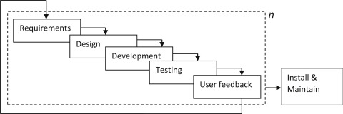

**Fig.1.5**

**1.6. INTRODUCTION TO SOFTWARE USE**

The Personal Diary Application has been developed using the **C programming language**, which provides efficient control over system resources and file management. The application utilizes standard C libraries such as stdio.h, string.h, time.h, and dirent.h to handle file input/output, date and time operations, string manipulation, and directory traversal. These libraries play a crucial role in managing diary entries, organizing them into folders, and validating date formats.Development was carried out using a text editor or Integrated Development Environment such as **Visual Studio Code**, or **Dev C++**, which offer useful features like syntax highlighting, debugging tools, and project organization. These tools help streamline the development process and make the code base easier to manage.

Overall, the combination of the C programming language, standard libraries, compiler tools, and a text editor or IDE forms the software backbone of the Personal Diary Application, ensuring a smooth and efficient development and execution environment.

**2. SYSTEM RECOMMENDATION:**

The minimum requirements for the system are:

**2.1.**  **HARDWARE:**

• PC with Pentium II Processor (260 MHz) or latest

• 32 MB of RAM or more

• Color Monitor (Preferably)

• Hard disk with at least 50 MB of free space

**2.2. SOFTWARE:**

• OS Windows (Windows XP, Windows 7, Windows 8, Windows 10, Linux)

**3. PROBLEM FACED**

The main problem faced while developing this application are as follows:

• Complexity on coding .

• As we were not familiar with the C Programming concepts in C language, at first it was very difficult for us to understand its working style and different features used in it such as object and class concepts.

• Difficulty in using and understanding the different tools.

• Due to lack of different feature and tools in our software we were unable to make our project effective and attractive.

• Faced quite a difficulty putting the BS feature in this code as there is the vast years in AD and BS.

1. **SYSTEM DESIGN**
2. **Algorithm**
3. Start the application
4. Show main menu and prompt user for choice:
   * 1. Add Entry
     2. View Entry
     3. Edit Entry
     4. Delete Entry
     5. List All Entries
     6. Exit
5. If invalid, show error → return to menu
6. When the user choose the option 1 then Ask: Use today’s date or enter manually?
7. If today → ask format (AD/BS) → fetch today’s date
8. Else → ask format → input date → validate (no future)
9. Create path: /AD or BS/YYYY/MM/DD
10. Show a motivational quote with timestamp
11. Accept entry lines until user types "Thanku" and save, close file → confirm success
12. After adding the entry when the user choose enter the option 2 then ask for date
13. If file exists → display contents, else → show "Entry not found"
14. After viewing the entry when the user enter the option for editing then ask the user for format and date
15. If file exists → show contents → overwrite with new lines until "Thanku" and save and close, else → show "Entry not found"
16. When user enter the option for deleting ask for format and date
17. If file exists → delete → show "Entry deleted", else → show "Entry not found"
18. When user enter the listing option then list entries under /AD/ and /BS/ by traversing folders
19. Show exit message → terminate program
20. Loop back to main menu until Exit is chosen
21. End
22. **Flowchart**

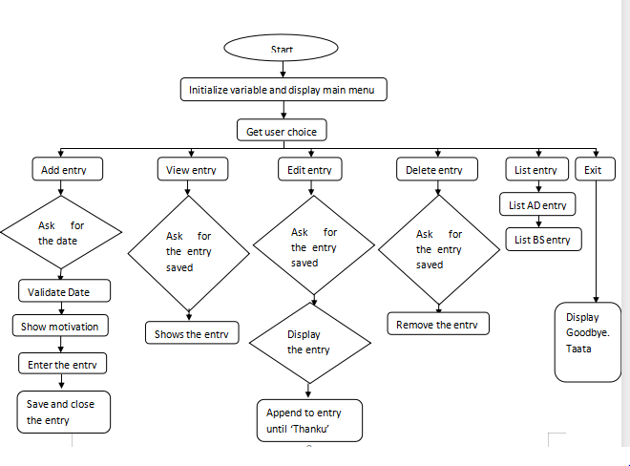

**Fig:4.B**

**5. SNAPSHOTS OF THE SYSTEM**

1. Menu

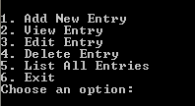

1. Add entry

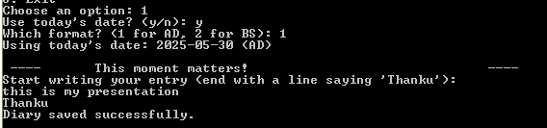

1. View entry

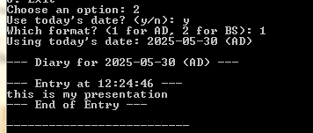

1. Edit entry

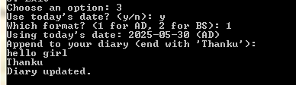

1. List all entry

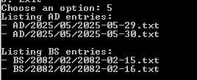

1. Delete entry

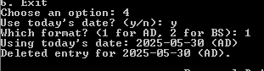

**6. CONCLUSION**

The Personal Diary Application is a simple yet functional tool designed to help users document their daily experiences in a structured and organized way. It supports both the Gregorian and Nepali calendar formats, giving user’s flexibility in how they date their entries. With essential features such as adding, viewing, editing, deleting, and listing diary entries, the application provides a user-friendly interface for managing personal records.

The system efficiently organizes entries into a hierarchical folder structure based on year and month, ensuring easy navigation and access. The inclusion of motivational quotes also adds a personalized touch, making the writing experience more engaging and uplifting.

While the application serves its core purpose effectively, it also presents several limitations, including the absence of security features, lack of search and multimedia support, and no data backup or synchronization. These constraints open doors for future enhancements, such as user authentication, cloud integration, advanced date handling, and modern user interfaces.

Overall, this project demonstrates a strong foundation in file handling, user interaction, and date management in C programming. It lays the groundwork for further development into a more feature-rich, secure, and user centric digital diary system.

1. **BIBLIOGRAPHY**

• http://stackoverflow.com/questions/tagged/c%2B%2B

•• http://WWW.cplusplus.com/reference/istream/iostream/

•Project instructor and mentor Mr.Nabin Dhital Sir’s Help and Guidance.